* SQLite Database

SQLite is a Structure query base database, open source, light weight, no network access and standalone database. It support embedded relational database features.

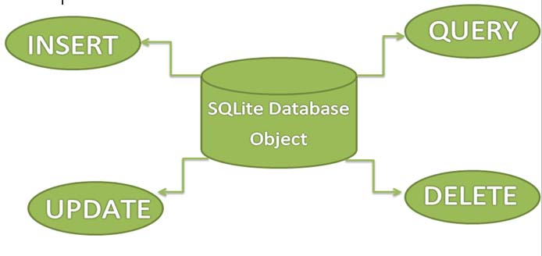

Whenever an application needs to store large amount of data then using sqlite is more preferable than other repository system like [SharedPreferences](https://abhiandroid.com/programming/shared-preference) or saving data in files.

SQLite is an in-process library that implements a [self-contained](https://www.sqlite.org/selfcontained.html), [serverless](https://www.sqlite.org/serverless.html), [zero-configuration](https://www.sqlite.org/zeroconf.html), [transactional](https://www.sqlite.org/transactional.html) SQL database engine. The code for SQLite is in the [public domain](https://www.sqlite.org/copyright.html) and is thus free for use for any purpose, commercial or private. SQLite is the [most widely deployed](https://www.sqlite.org/mostdeployed.html) database in the world with more applications than we can count, including several [high-profile projects.](https://www.sqlite.org/famous.html)

The SQLite project was started on [2000-05-09](https://www.sqlite.org/src/timeline?c=2000-05-29+14:26:00). The future is always hard to predict, but the intent of the developers is to support SQLite through the year 2050. Design decisions are made with that objective in mind.

We the developers hope that you find SQLite useful and we entreat you to use it well: to make good and beautiful products that are fast, reliable, and simple to use. Seek forgiveness for yourself as you forgive others. And just as you have received SQLite for free, so also freely give, paying the debt forward.

SQLite is an embedded SQL database engine. Unlike most other SQL databases, SQLite does not have a separate server process. SQLite reads and writes directly to ordinary disk files. A complete SQL database with multiple tables, indices, triggers, and views, is contained in a single disk file. The database [file format](https://www.sqlite.org/fileformat2.html) is cross-platform - you can freely copy a database between 32-bit and 64-bit systems or between [big-endian](http://en.wikipedia.org/wiki/Endianness) and [little-endian](http://en.wikipedia.org/wiki/Endianness) architectures. These features make SQLite a popular choice as an [Application File Format](https://www.sqlite.org/appfileformat.html). SQLite database files are a [recommended storage format](https://www.sqlite.org/locrsf.html) by the US Library of Congress. Think of SQLite not as a replacement for [Oracle](http://www.oracle.com/database/index.html) but as a replacement for [fopen()](http://man.he.net/man3/fopen)

Android has built in SQLite database implementation. It is available locally over the device(mobile & tablet) and contain data in text format. It carry light weight data and suitable with many languages. So, it doesn’t required any administration or setup procedure of the database.